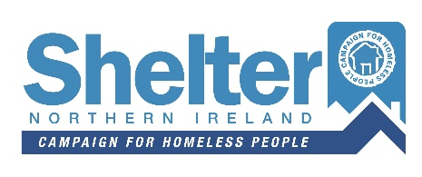
Fundraising Event Form
To be completed by Shelter NI | Event ref:

Full name
Address
 |  |  |  | Post Code
Phone |  | Email

Event Information
What are your reasons for raising funds for Shelter NI?
Date |  |  |  |  |  |  | Time
Type of the event
Coffee Morning |  |  | Baking Sale |  |  | Marathon |  |  |  | Other
If you have selected "other" please specify:
Name and Venue Address

Declaration
By returning this this form you agree to the Shelter NI 'Terms and Conditions' as listed below.
1. I understand that Shelter NI will, in no way, be liable for any claim any injury or loss that might occur as a result of this event.
2. I agree to send all proceeds of the event to Shelter NI as quickly as possible after the event.

Would you like to receive information about Shelter NI’s work time to time by email?
Yes |  | No

Signature |  | Date

Please return completed form, signed and dated to:
Shelter NI, 58 Howard Street, BT1 6PJ
or
events@shelterni.org

